Helicopters

Subject:  Related Subjects: | Grade Level(s):  Length of Lesson: | Type: Inquiry / Design / Project  Keywords:

Lesson Overview
Use this section to describe at a high level what the lesson is. Should be no more than 3-4 lines.

Lesson Focus
What is the central question or phenomenon being investigated? What problem are they trying to solve?

Lesson Objective(s) | By the end of this lesson, students will…  - Learn the concepts of attraction, repulsion, friction, polarity, and charge.

Lesson Timing

5 minutes | Introduce the Lesson
30 minutes | ...

Materials | - "Cardboard, 3 1/2"" x 1 1/4"" "  - Drinking straw  - Paper  - Scissors  - Tape  - Craftsticks  - Hot Glue Gun  - Glue sticks  - Wood Dowels  - "1/8"" Dowel"  - Sand paper
Instructor Prep | - Step 1
Related Resources | - List related lessons/ppts etc available from USC or outside, trusted orgs

Lesson Plan

Introduction
Introduce students to the learning goals and make connections to past and present learning experiences. Stimulate interest and prompt students to identify their own questions about the topic. This can link the lesson to real world examples, introduce associated STEM careers, and assess their prior knowledge on the topic.

- Step 1

Procedure
- Step:
- 1. –Cut sheet of paper in half length-wise.
- 2. –Fold & unfold “half sheet” in half width-wise creating a “middle mark”
- 3. –Cut along “middle mark” of half sheet mark 1/3 of the way on each side.
- 4. –Fold along cuts and paper clip in place (this is the bottom half).
- 5. –Cut ¾ way down the middle of top half.
- 6. –Fold paper in opposite directions to create to flaps.

- Flying Stick
- 1. Cut an 7" dowel
- 2. Sand two sides of the top of the dowel at a 30 degree angle
- 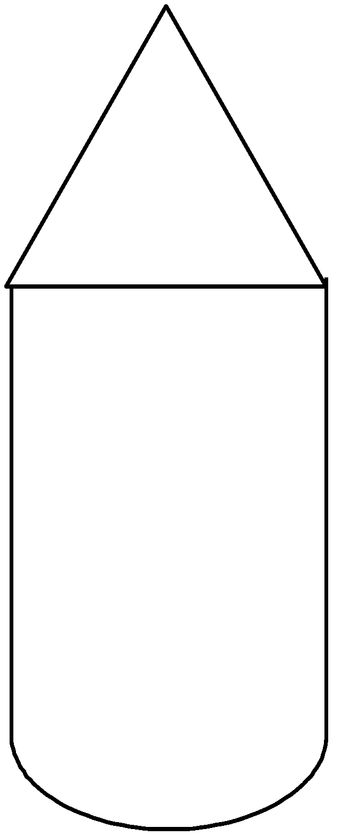. It shouldn’t be sharpened like a pencil. It should be flat on two sides
- 3. Sand one end of both craftsticks so that one end is more narrow. 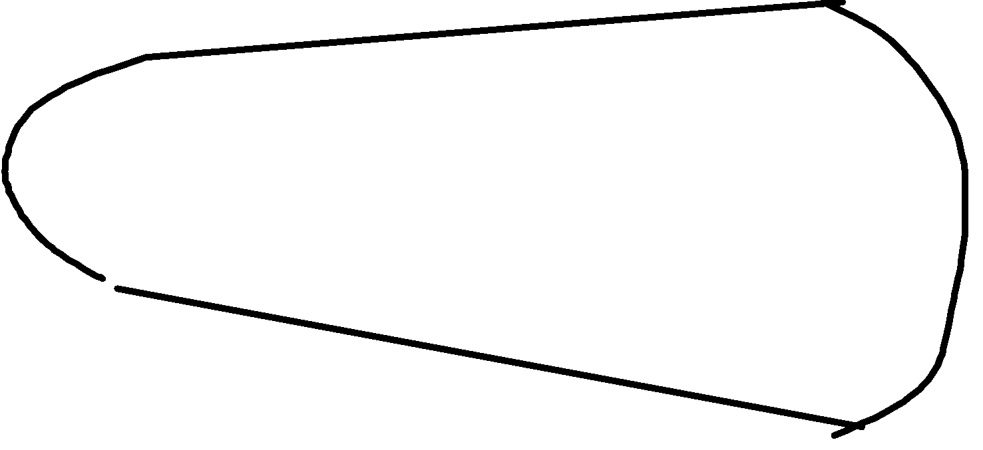
- 4. Glue the end of one craftstick so that it extends one way from the dowel.
- 5. Glue the end of second craftstick so that it extends the other way from the dowel.
- 6. Hold dowel in between yours hand, slide one hand toward you and the other away and release.

Wrap-up
End the lesson with some final discussions about what students designed/discovered. Connect their activity back to the focus question/problem, real world examples, and STEM careers.

Also include notes about any special cleanup considerations

Lesson Background for Teachers

Suggested Real-World STEM Connections
- List possible related Role Models in STEM (with details and links to more reading). Give suggestions for examples of scientists/engineers who are from underrepresented groups in STEM in related careers.
- List related real-world engineering problems and examples

Lesson Variations and Options
Include descriptions of alternative methods or ways to present things.

Explanation
Describe the background concepts and explanations behind the lesson. This can be more in depth than a teacher/instructor would actually share with students.

Key Concepts and Vocabulary
- Word 1: Grade Appropriate Definition
- Word 2: Grade Appropriate Definition

Safety Notes
- Safety instruction

